**LAB 6- Index and Match Function Lab**

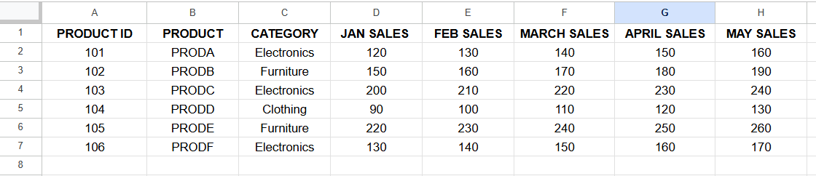

**1. Use INDEX and MATCH to find the sales for Product C in March.**

**2. Use INDEX and MATCH to find the category for Product E.**

**3. Use INDEX and MATCH to find the maximum sales for Product B**

**across all months.**

**4. Use INDEX and MATCH to find the month with the maximum sales for**

**Product A.**

**5. Use INDEX, MATCH, and SUMIF to sum the sales for all products in the "Electronics" category for April.**

**6. Use INDEX and MATCH to calculate the average sales for Product D across all months.**

**7. Use INDEX and MATCH to find the sales for Product ID 105 in May.**

**8. Use INDEX and MATCH to create a dynamic lookup where the user can input a product and a month, and the formula returns the corresponding sales.**

**Solution:**

